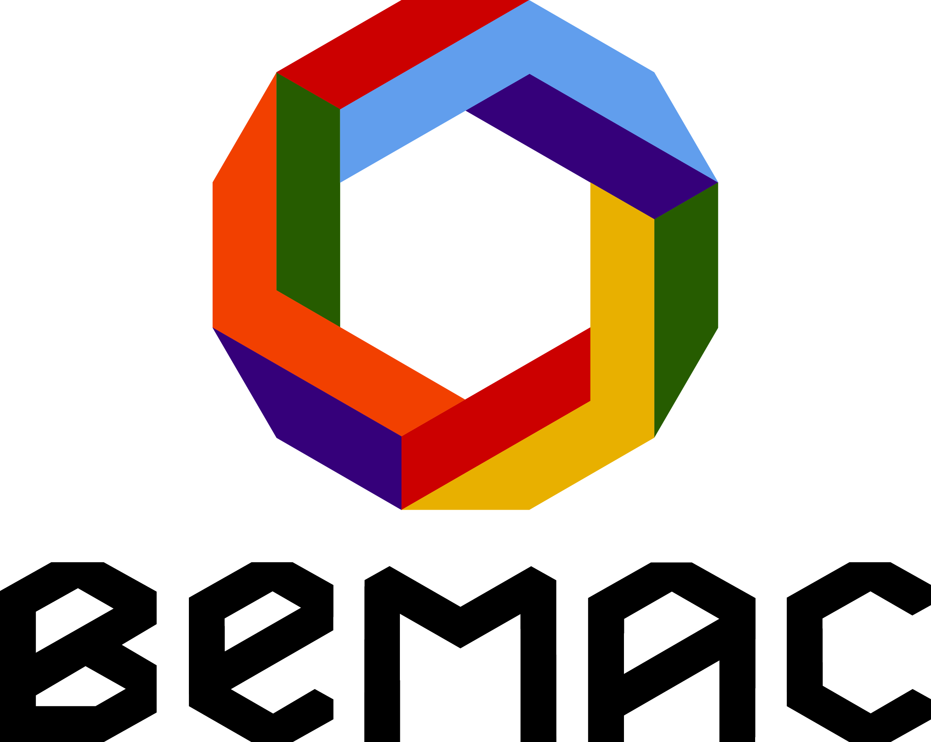

Queensland Multicultural Week 2013

September 1st – 9th, 2013
Zillmere State School, Murphy Road, Zillmere
EXPRESSION OF INTEREST
DANCE WORKSHOPS: “THE TRANSCULTURAL DANCE FESTIVAL” 2013

WHAT
BEMAC is looking for a diverse range of multicultural dance workshops as part of “The Transcultural Dance Festival” a program initiative for the Queensland Multicultural Week in September, 2013.This exciting program of workshops, performances and flash mob conspiracies will take place across Brisbane over the whole week, and will give dancers and members of the public an opportunity to participate in a range of traditional and contemporary dance forms from around the world.
The workshops are expected to be run in a fun, creative, culturally based workshops for the general public. Dance genres can range from Indian, Flamenco, Balinese, Ethiopian, Brazilian, Scottish and Celtic, Morris, Rwandan, Philippine, Polish, Indonesian, Colombian, West African, South Pacific Island, Cuban, Bulgarian, Bollywood, Hip-Hop, Palestinian, Contemporary & more.
CRITERIA
Workshops need to have a diverse cultural base and we encourage groups, individuals from diverse backgrounds to apply.
OUTCOME
A ticketed performance at the Queensland Multicultural Centre, 102 Main Street, Kangaroo Point, QLD 4169
DETAILS

LENGTH OF WORKSHOPS: 1-2 hours (negotiable)
VENUES: TBC
DATES: Queensland Multicultural Week September 1st – 9th, 2013
BEMAC PROVIDES: the venues, marketing and publicity support, limited technical equipment and administration support

ARTIST/S PROVIDE

- BIO
- A DESCRIPTION OF WORKSHOP
- IMAGES
- NOMINATE A FEE

CONTACT: BEMAC (07) 3391 4433 or producer@bemac.org.au

